E11 Circuit Lab Work

03/07/2025

1. *Resistors in Series*

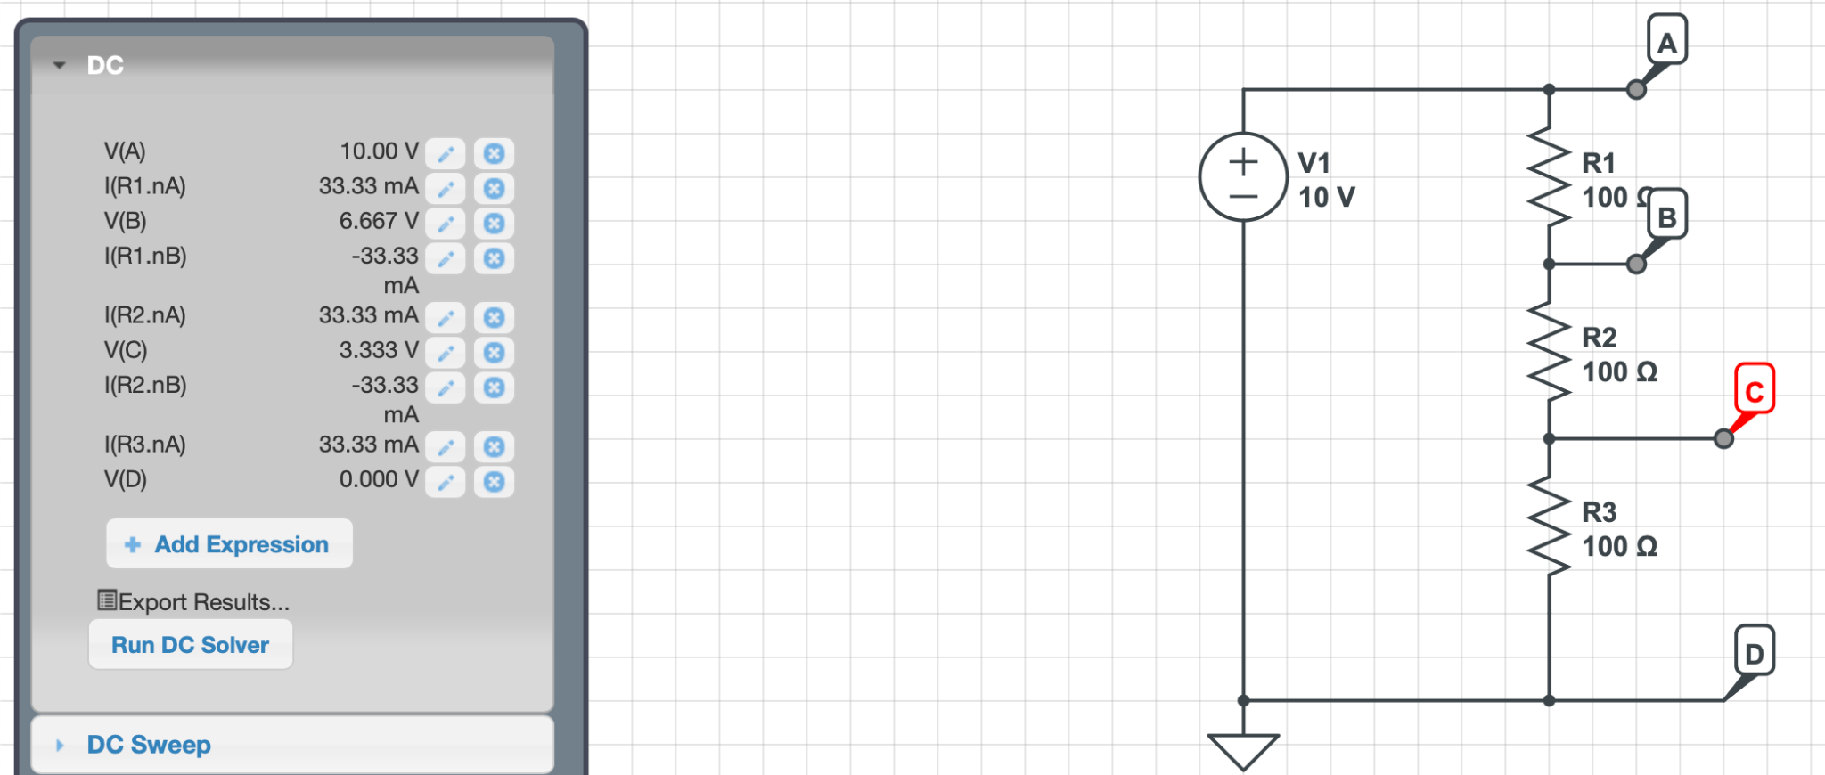

* As more resistors get added to the circuit, the Voltages begin to decrease more at each node, which makes sense because of ohm since the current within the entire circuit is decreased due to V/R(total) = I where R(total) = R1+R2+R3

*2: Resistors in Parallel*

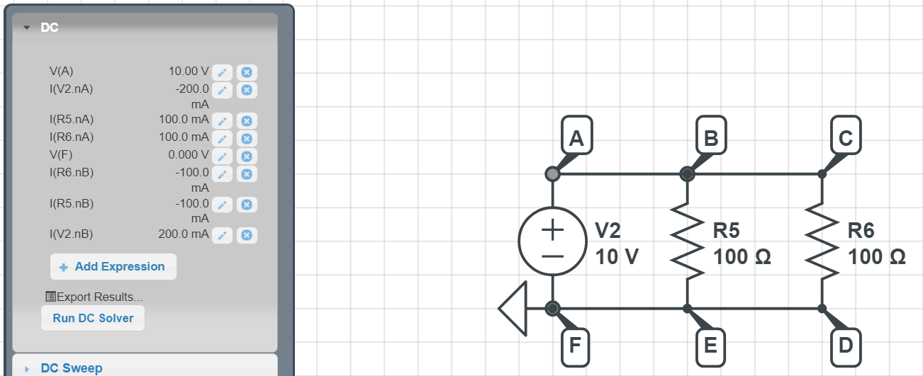

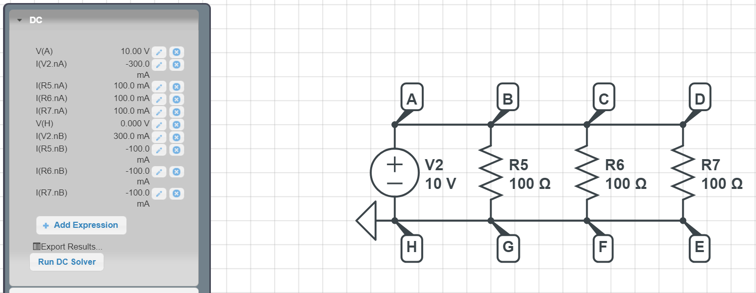

* Adding a third resistor in parallel doesn’t change the voltages at any points, and the current at each node remains the same, with the exception of the first and last nodes, which increased from 200 mA to 300 mA/decreased from -200 mA to -300 mA.

*3: Resistors in Series and Parallel*

*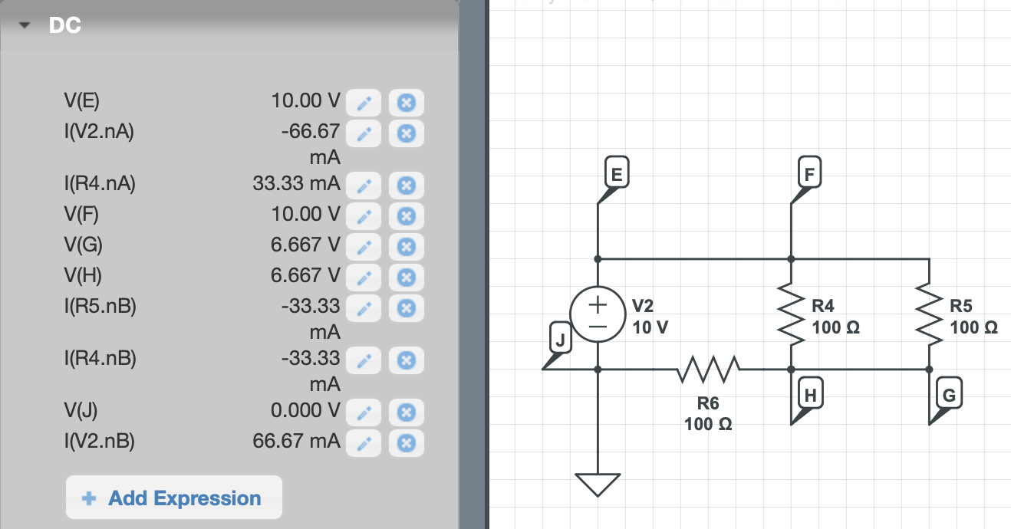*

The voltage across the resistors in parallel dropped less than the resistor in series. The current across the resistors in parallel decreased less than the resistor in series as well. Resistors in series will result in a greater decrease in voltage than resistors in parallel. So for practical reasons you want to connect things in parallel rather than in series so you have a greater voltage output.

*4: Powering light bulbs*

Power =V \* I = 10V \* 0.1A = 1W

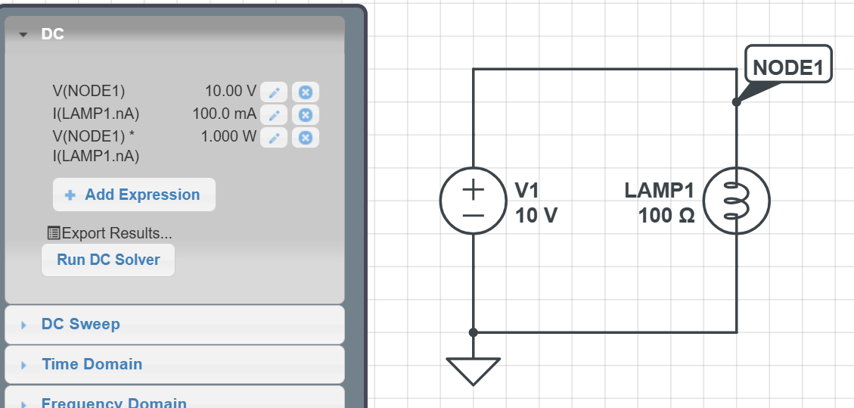

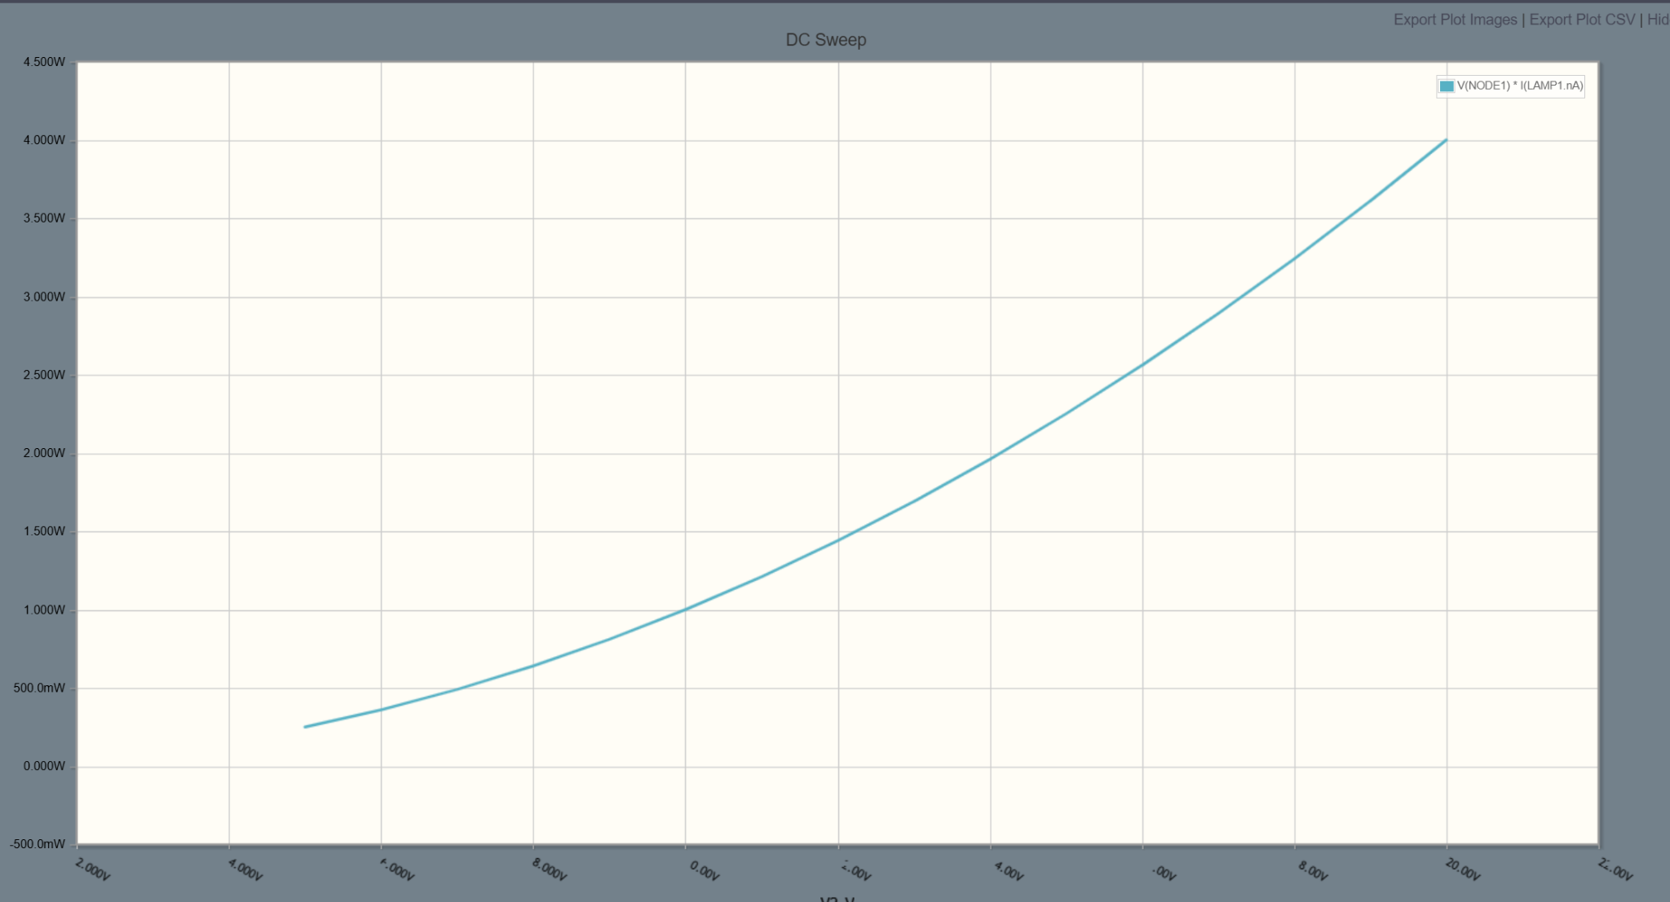

4.1 Power change by V

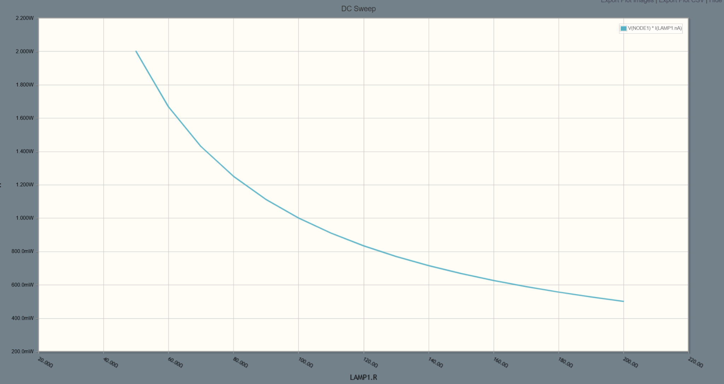

4.2 Power change by R

*5: Capacitor circuit*

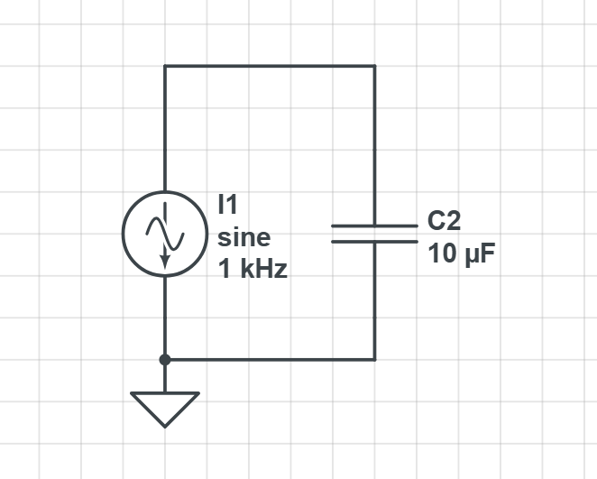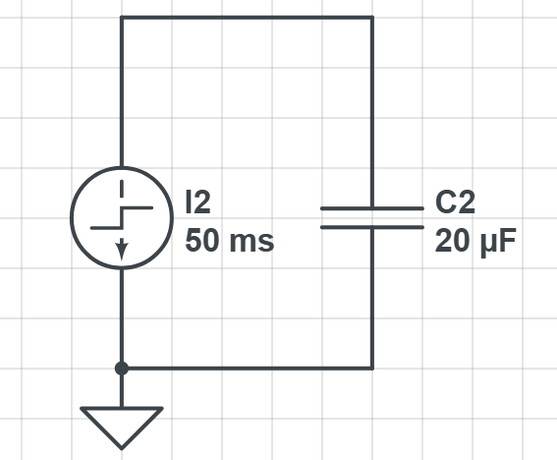

Sine:

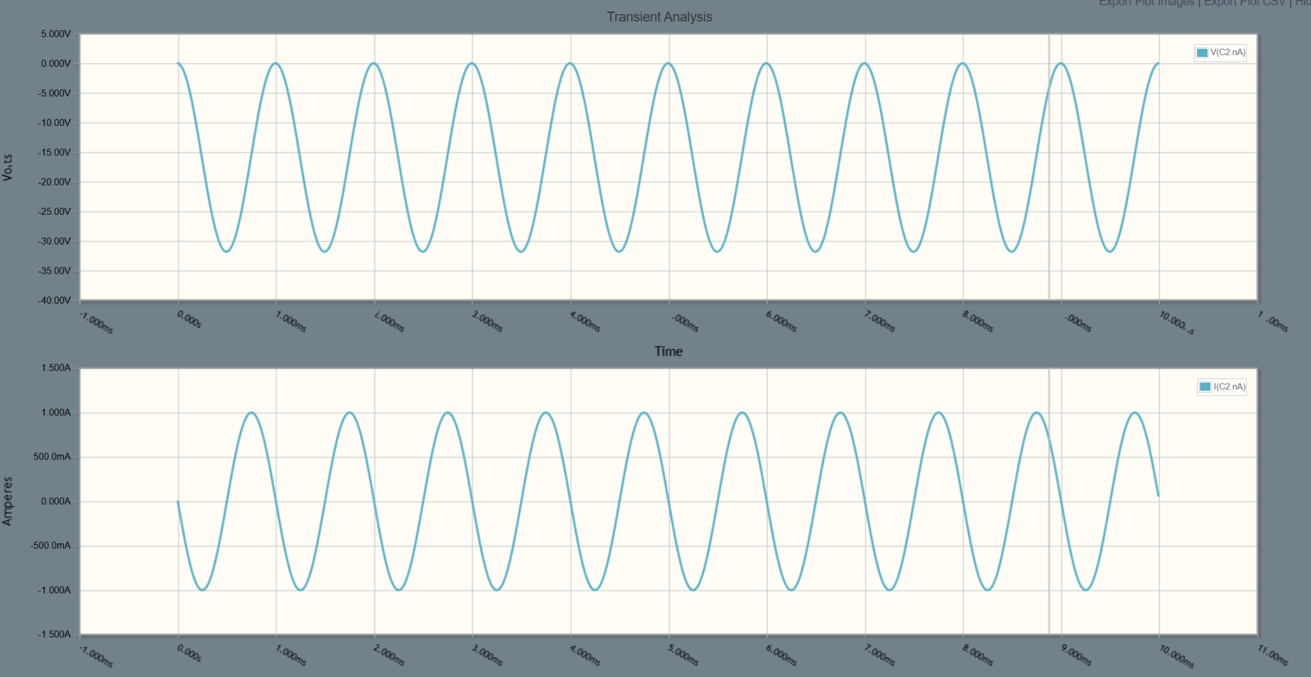

Step:

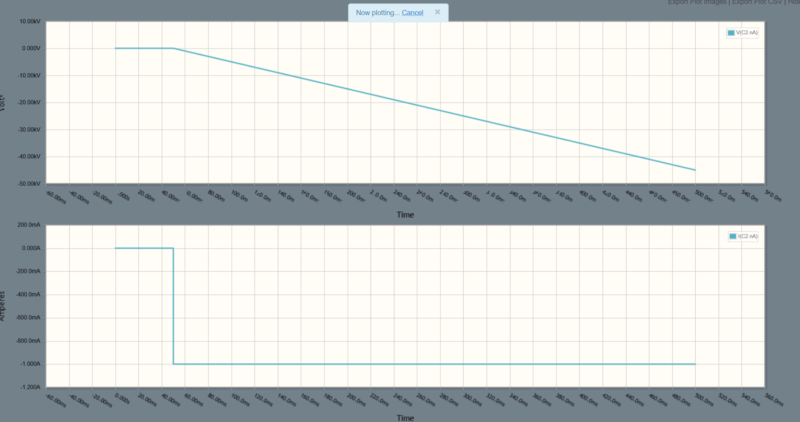

Voltage’s absolute value increases slower when the capacitance increases. The value of the current remains constant.

*6: RC Circuits*

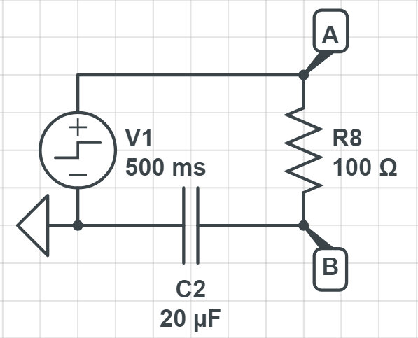

-10V, 500 ms, 100 Ohms, 10 uF

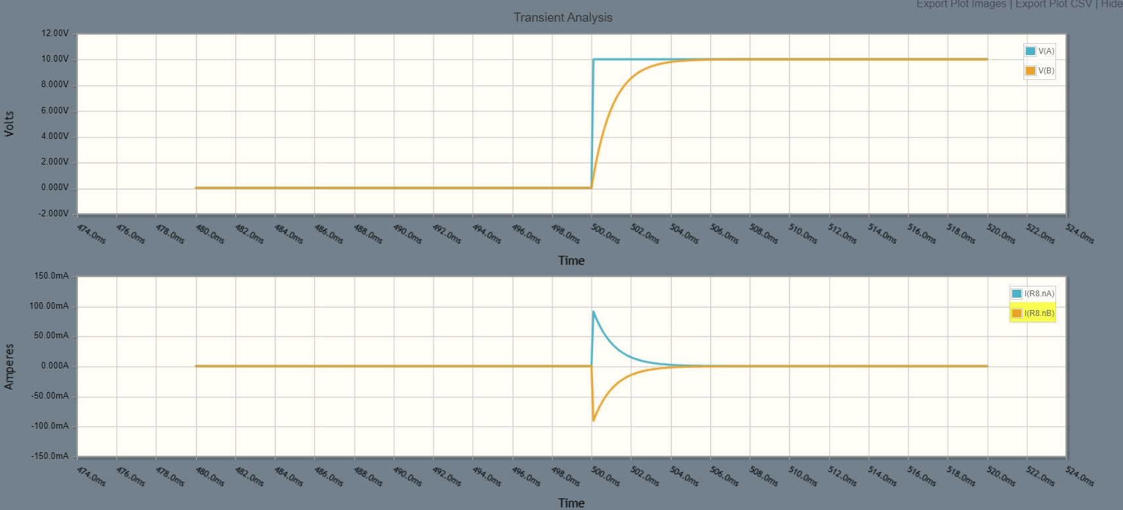

-10V, 500 ms, 200 Ohms, 10 uF

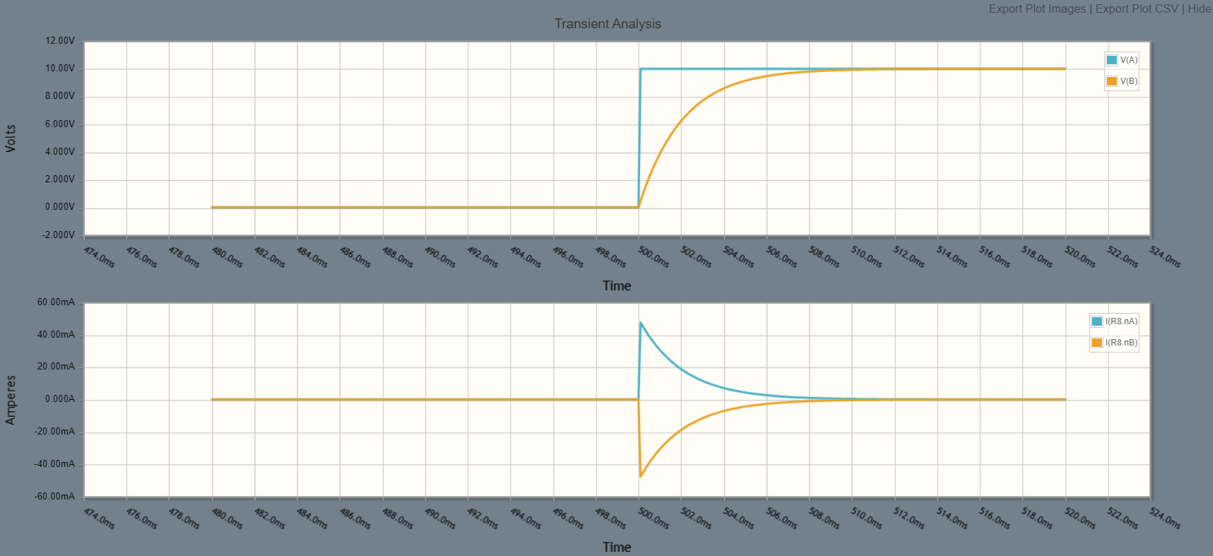

-10V, 500 ms, 100 Ohms, 20 uF

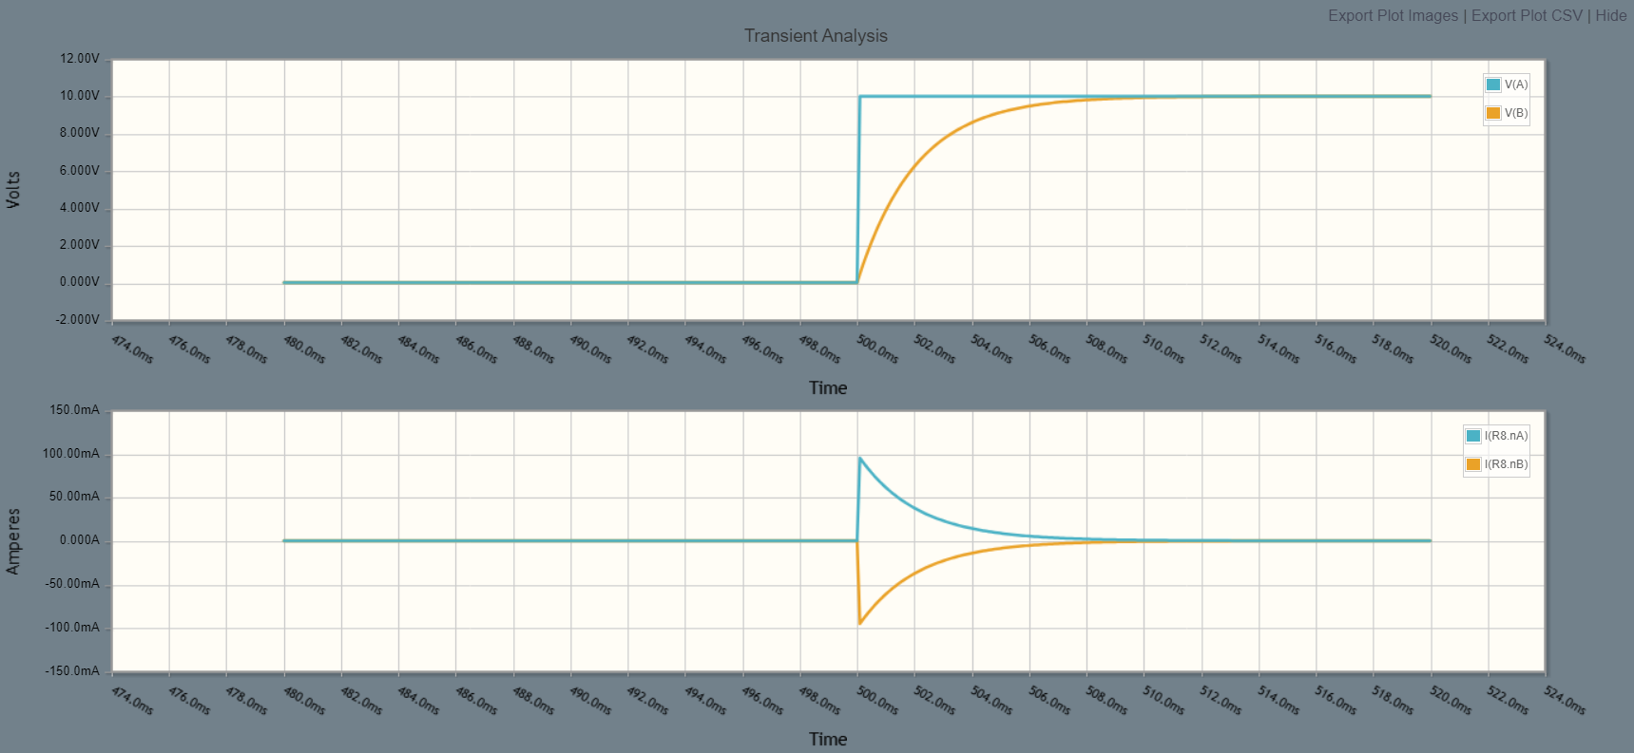

* R & C are inversely proportional to t in e^(-t/RC), so we would expect the tail on the changes to lengthen when increasing R and/or C, which we do. Furthermore, in each of the second two tests, I increased R, then C, by a factor of 2, which should result in the same graph, which it does.

*7. RC filter*

-100Hz, 1uF, 1k Ohms

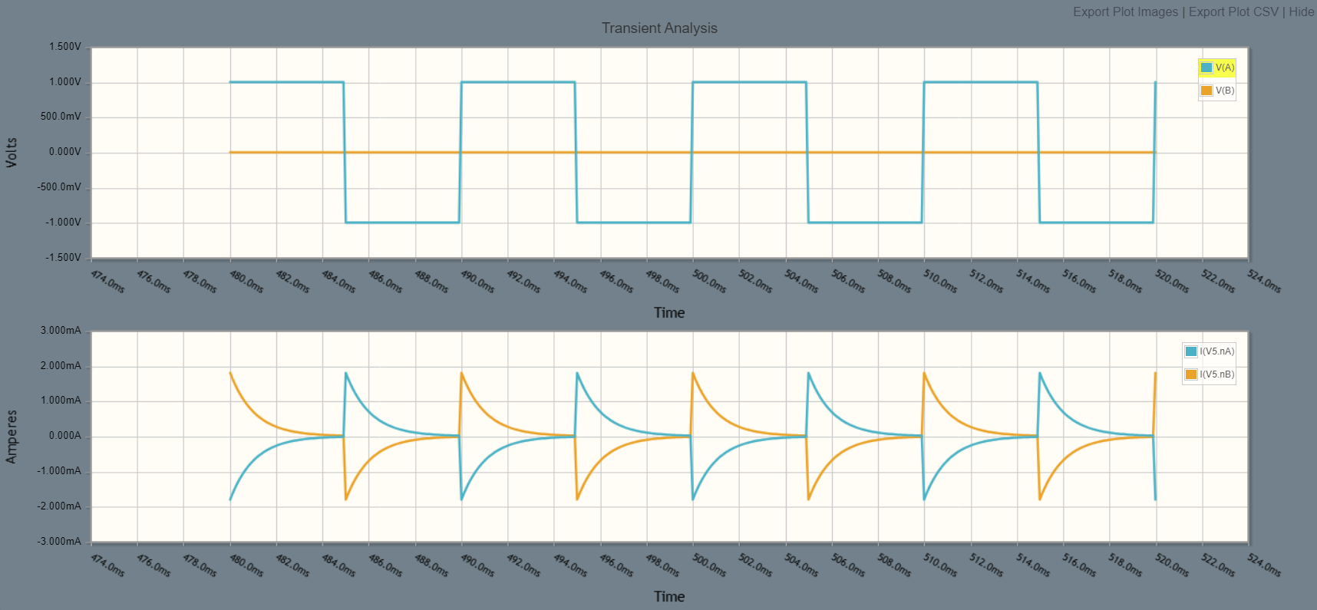

-100Hz, 5uF, 1k Ohms

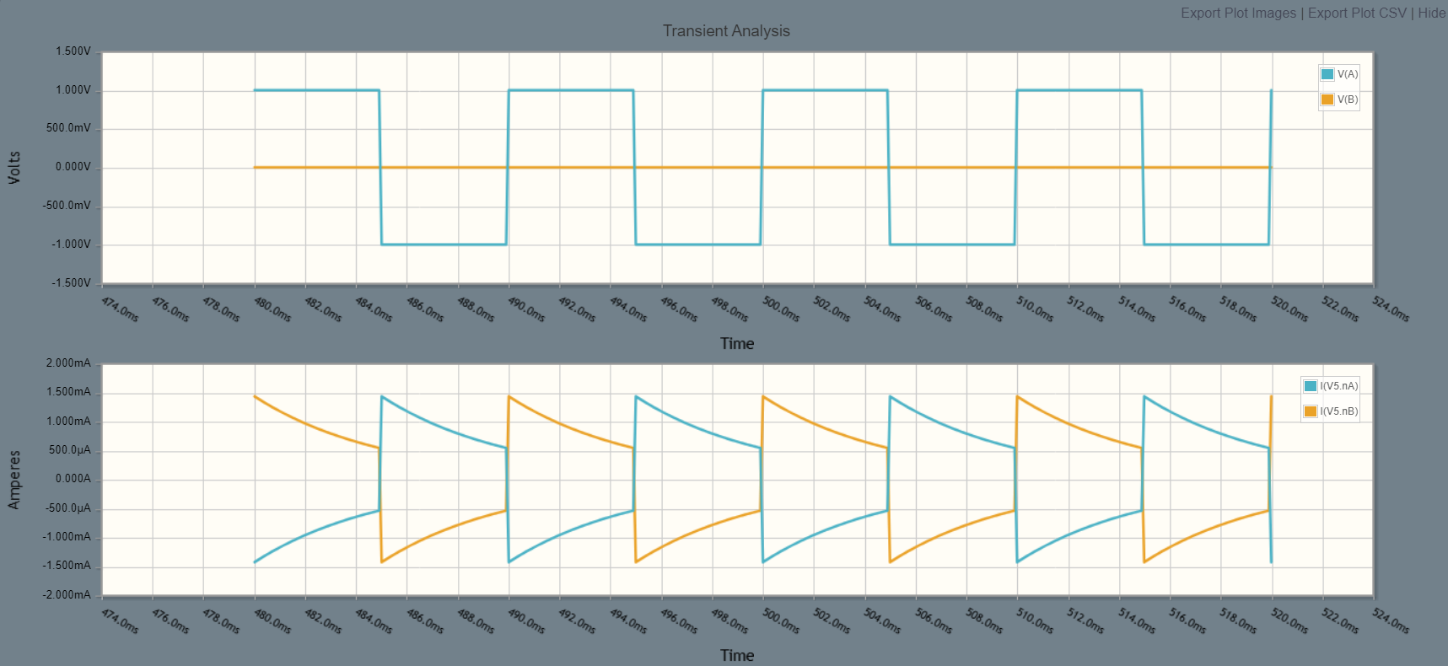

-100Hz, 1uF, 5k Ohms

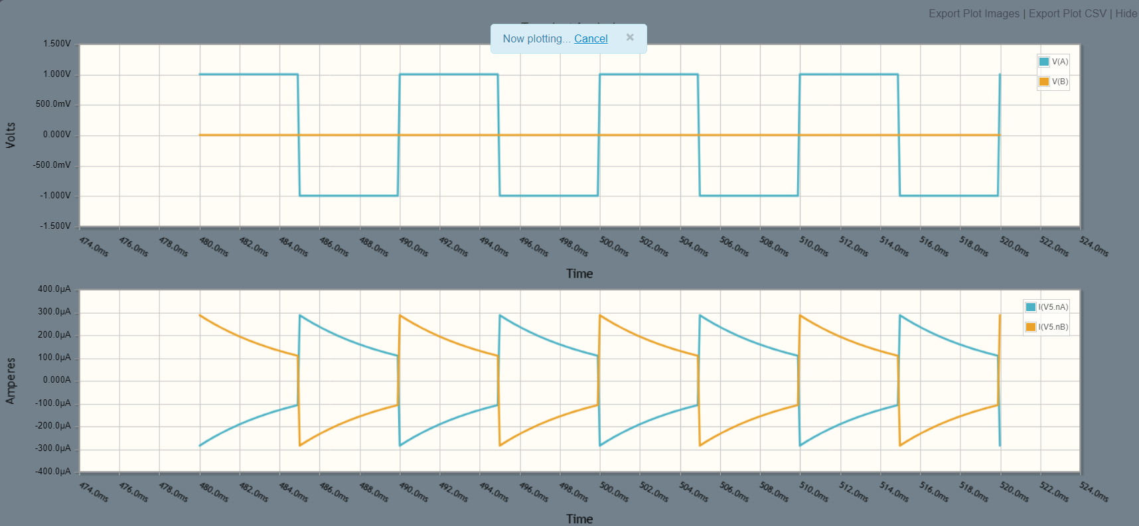

-500Hz, 1uF, 1k Ohms

